**API specification**

members：窦锦涛 ID:16301085

厉欣林 ID:16301096

our group use bomb to finish the login and register

**the package dependency**

login:

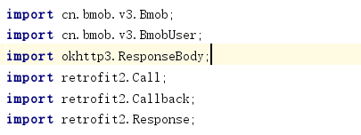

register:

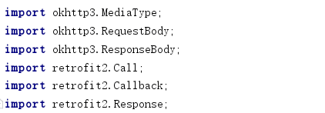

bombservice:

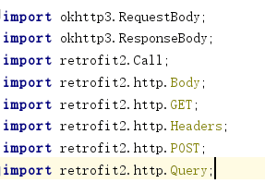

client:



the implement:

Login:

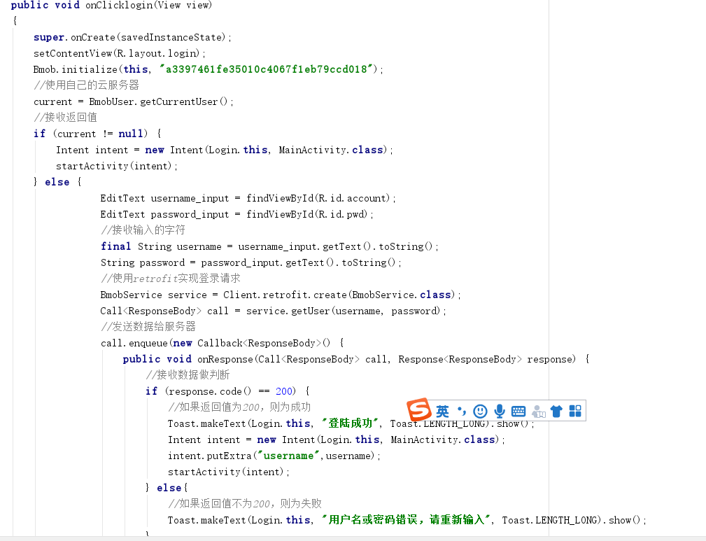

register:

